**MODULE I**

1. Define asymptotic notation? Arrange the following functions in increasing order

of asymptotic growth rate.



1. State Master’s Theorem. Find the solution to the following recurrence equations

using Master’s theorem.

* 1. T (n) = 8T(n/2) + 100 n2
  2. T (n) = 2T(n/2) + 10 n

1. Define Big O, Big Ω and Big Ɵ Notation and illustrate them graphically.
2. Solve the following recurrence equation using recursion tree method

T(n) = T(n/3) + T(2n/3) + n , where n>1

T(n) = 1, Otherwise

1. Explain the iteration method for solving recurrences and solve the following recurrence equation using iteration method.

T(n) = 3T(n/3) + n; T(1) = 1

1. Determine the time complexities of the following two functions fun1( ) and fun2( ).
   1. int fun1(int n)

{

if (n <= 1) return n;

return 2*fun1(n-1);

}

* 1. int fun2 (int n)

{

if (n <= 1) return n;

return fun2 (n-1) + fun2 (n-1)

}

1. Is [2^{^{n+1}}=O(2^{2n})](https://kmctce.etlab.in/outcomes/cobasedquestions/view/2324)?  Is [2^{2n}=O(2^{2n})](https://kmctce.etlab.in/outcomes/cobasedquestions/view/2324)? Justify your answer
2. What is the need of asymptotic analysis in calculating time complexity? What are the

notations used for asymptotic analysis?

1. Find the time complexity for addition of two matrices
2. Define time complexity and space complexity. Write an algorithm for adding n natural

numbers and analyse the time and space requirements of the algorithm.

1. State Master’s theorem for solving recurrences.
2. Solve the recurrence T(n) = 3T(n-2), using iteration method
3. State the conditions in recurrences where Master Theorem is not applicable.
4. Solve using Masters theorem:

i) T (n) = 3 T (n/4) + n log n

ii) T(n) = 9 T(n/3) + n

1. Using Recursion Tree method, Solve T(n)= 2T(n/10)+ T(9n/10)+n. Assume constant time for small values of n.
2. Analyse the complexity of the following function:

void function(int n)

{

int count = 0;

for (int i=n/2; i<=n; i++)

for (int j=1; j<=n; j = 2 * j)

for (int k=1; k<=n; k = k * 2)

count++;

}

1. Solve using Iteration method T(n)=2T(n/2)+n,T(1)=1
2. Solve using Recursion Tree method

T(n)=3T(n/4)+n2

19.Solve the recurrence using recursion tree method:

T(1) = 1

T(n) = 3T(n/4) + cn2

20. Solve using iteration method.

i) T(n)= 2 T(n/2) + n

ii) T(n) = 2 T(n/2) + n2

21. Analyse the complexity of the following functions

i)function(int n)

{ if (n==1) return;

for (int i=1; i<=n; i++)

{ for (int j=1; j<=n; j++)

{ printf("*"); break; }

}

}

ii) void function(int n)

{

int i = 1, s =1;

while (s <= n)

{

i++;

s += i;

printf("*");

}

}

22. Let 𝑓(𝑛) = 3𝑛3 + 2𝑛2 + 3 for an algorithm, Let 𝑔(𝑛) = 𝑛3. Prove that f(n) of this

algorithm is in 𝑂(𝑛3)

23. Solve the recurrence 𝑇(𝑛) = 3𝑇 (𝑛/4) + 𝑛𝑙𝑜𝑔𝑛. using Master theorem.

24.Give the general idea of the substitution method for solving recurrences. Solve the

following recurrence using substitution method.

𝑇(𝑛) = 2𝑇 (𝑛/2) + 𝑛

25. Solve the following recurrence using recursion tree method

1) 𝑇(𝑛) = 𝑇 (𝑛/3) + 𝑇 (2𝑛/3 ) + 𝑐𝑛

2) 𝑇(𝑛) = 2𝑇 (𝑛/2) + 𝑛

26. Let 𝑓(𝑛) = 7𝑛 + 4.Prove that this is of the order of 𝛺(𝑛).

27. Solve the following recurrence using Master theorem.

a) 𝑇(𝑛) = 8𝑇 (𝑛/2) + 𝑛2

b) 𝑇(𝑛) = 2𝑇 (𝑛/2) + 𝑛

28. Solve the following recurrence using recursion tree method:

1) 𝑇(𝑛) = 𝑇 (𝑛/2) + 1, 𝑇(1) = 1

2) 𝑇(𝑛) = 2𝑇 (𝑛/2) + 𝑛2, 𝑇(1) = 1

29. Perform complexity analysis for the following code segments:

1) For i=1 to n do

For j = 1 to n do

A=B * C

End for

End for

2) Function F(n)

{

If(n==0)

return(1)

Else

return (n*F(n-1))

}

**MODULE II**

1. Show any two topological ordering of the DAG given below.

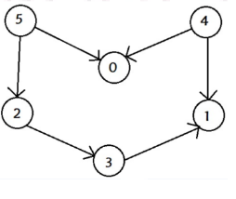

1. Construct the UNION operation using linked list representation of disjoint sets.
2. Write DFS algorithm and analyse its time complexity. Illustrate the

classification of edges in DFS traversal.

1. Find the strongly connected components of the digraph given below:

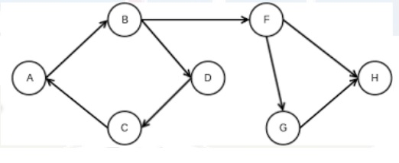

1. List the advantages of height balanced binary search trees over binary search trees? Explain various rotations in AVL trees with example.
2. Apply the following operations in the given AVL trees.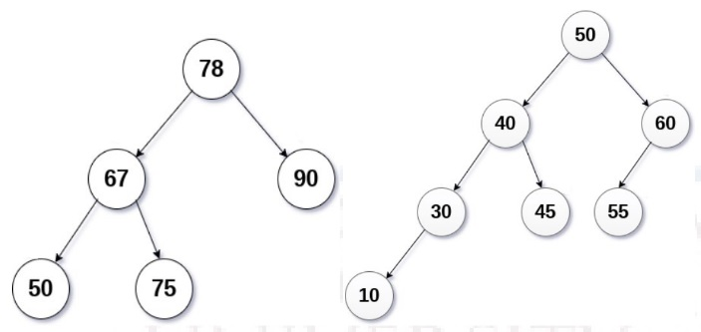

i) Insert 70 ii) Delete 55

1. Explain the rotations performed for insertion in AVL tree with example.

1. Write down BFS algorithm and analyse the time complexity. Perform BFS traversal on the given graph starting from node A. If multiple node choices are available for next travel,choose the next node in alphabetical order.

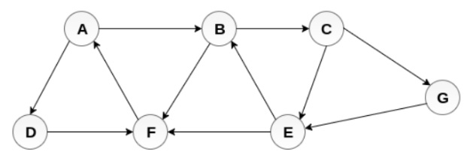

1. Demonstrate the minimum and maximum height of any AVL-tree with 7 nodes? Assume that the height of a tree with a single node is 0.
2. Define strongly connected components. How DFS can be used to find strongly

connected components?

1. Illustrate any three topological orderings of the given graph.

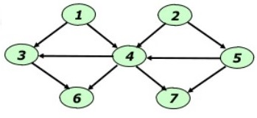

12Write DFS algorithm and analyse its time complexity. Illustrate the  
classification of edges in DFS traversal

13. Apply these algorithms on the following graph. Let A be the source vertex.

Analyse complexity of each algorithm.

i) BFS ii) DFS

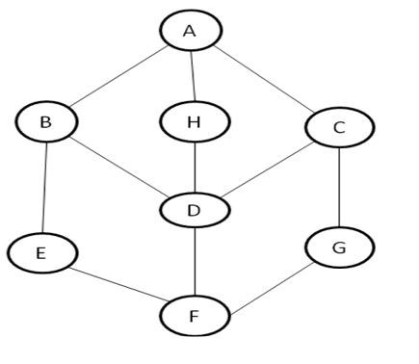

14. Write a short note on graph traversals

Perform BFS traversal on the above graph starting from node A. If multiple node

choices may be available for next travel, choose the next node in alphabetical order.

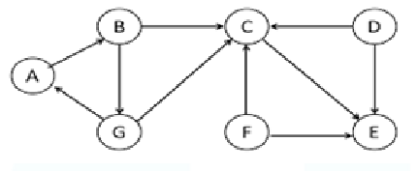

**15.** Define AVL tree. Construct an AVL tree by inserting the keys: 44, 17, 32, 78, 50,

88, 48, 62, 54 into an initially empty tree. Write clearly the type of rotation

performed at the time of each insertion

16. Define MAKE_SET(x), UNION(x,y) and FIND_SET(x) operations of disjoint

set data structure with a suitable example

17. Find any ONE topological ordering of the following the graph

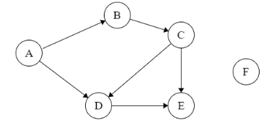

17. What are the operations supported by Disjoint Data Structure? Explain the

working of Disjoint Set Data Structure for computing Connected Components of

an undirected graph given in the following figure

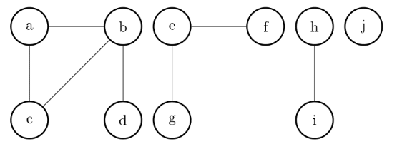

18. Perform the following operations in the given AVL trees.

1) Insert 54 in Tree 1 2) Delete 15 from Tree 2.

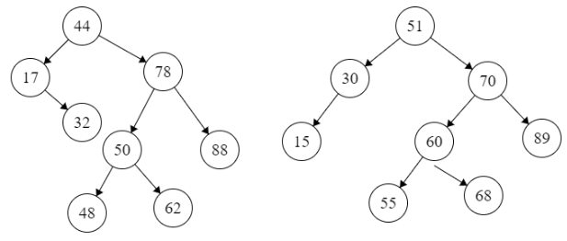

**MODULE III**

1.Develop the control abstraction for Divide and Conquer method.

2.Write an algorithm based on divide-and-conquer strategy to search an element in a

given list. Assume that the elements of list are in sorted order.

3.Write and explain merge sort algorithm using divide and conquer strategy using the data {30, 19, 35, 3, 9, 46, 10}. Also analyse the time complexity.

4.Compare Divide and Conquer and Dynamic programming methodologies.

5.Write an algorithm to merge 2 sorted arrays into a single sorted array

6.Explain Divide and Conquer strategy with example.

7. Show Strassen’s matrix multiplication.

[8.Write the control abstraction for Greedy design technique. Give a greedy algorithm for fractional knapsack problem.](https://kmctce.etlab.in/outcomes/cobasedquestions/view/6330)

[9.Write Dijkstra’s algorithm for single source shortest path. Perform its complexity analysis.](https://kmctce.etlab.in/outcomes/cobasedquestions/view/6329)

[10.Give Kruskal’s algorithm for minimum cost spanning tree computation. Apply the algorithm to find the minimum cost spanning tree for the following graph.](https://kmctce.etlab.in/outcomes/cobasedquestions/view/6327)

[[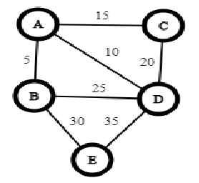](https://kmctce.etlab.in/outcomes/cobasedquestions/view/6327)](https://kmctce.etlab.in/outcomes/cobasedquestions/view/6327)

11.[Why Strassen’s matrix multiplication algorithm is better than traditional divide  
and conquer algorithm for multilpying two square matrices? What is the  
recurrence for the number of computational steps taken by Strassen’s algorithm  
and its time complexity?](https://kmctce.etlab.in/outcomes/cobasedquestions/view/6337)

[12.Compare the branch-and-bound technique from the backtracking technique.](https://kmctce.etlab.in/outcomes/cobasedquestions/view/6314)

[13.Compare Divide and Conquer and Dynamic programming methodologies.](https://kmctce.etlab.in/outcomes/cobasedquestions/view/6309)

[14.Construct the minimum spanning tree for the given graph using Kruskal’s algorithm. Analyse the complexity of the algorithm.](https://kmctce.etlab.in/outcomes/cobasedquestions/view/6307)

[[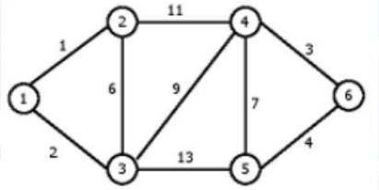](https://kmctce.etlab.in/outcomes/cobasedquestions/view/6307)](https://kmctce.etlab.in/outcomes/cobasedquestions/view/6307)

[15.Apply greedy algorithm for fractional knapsack to find the optimal ordering for loading the items in the knapsack. Let the knapsack capacity, M=15](https://kmctce.etlab.in/outcomes/cobasedquestions/view/5963)

[[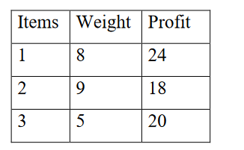](https://kmctce.etlab.in/outcomes/cobasedquestions/view/5963)](https://kmctce.etlab.in/outcomes/cobasedquestions/view/5963)

[16.Apply Kruskal algorithm to find minimum cost spanning tree for the following graph.](https://kmctce.etlab.in/outcomes/cobasedquestions/view/5961)

[[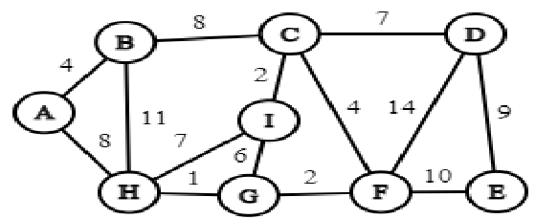](https://kmctce.etlab.in/outcomes/cobasedquestions/view/5961)](https://kmctce.etlab.in/outcomes/cobasedquestions/view/5961)

17.[Apply Dijkstra’s algorithm for single source shortest path to solve the following graph. Assume the source as node A](https://kmctce.etlab.in/outcomes/cobasedquestions/view/5956)

[[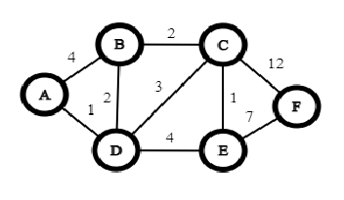](https://kmctce.etlab.in/outcomes/cobasedquestions/view/5956)](https://kmctce.etlab.in/outcomes/cobasedquestions/view/5956)

[18.Illustrate the divide and conquer approach by applying 2 way merge sort for the input array: [15,12,14,17,11,13,12,16]. Write the recurrence for merge sort and give the complexity.](https://kmctce.etlab.in/outcomes/cobasedquestions/view/5953)

[19.Compute the Minimum Spanning Tree and its cost for the following graph using Kruskal’s Algorithm. Indicate each step clearly.](https://kmctce.etlab.in/outcomes/cobasedquestions/view/6637)

[[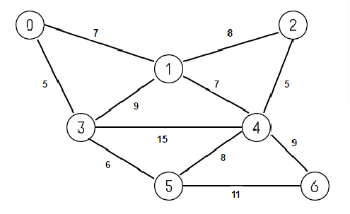](https://kmctce.etlab.in/outcomes/cobasedquestions/view/6637)](https://kmctce.etlab.in/outcomes/cobasedquestions/view/6637)

[20.Find the optimal solution for the following fractional Knapsack problem.  
n=4, m = 60, W={40, 10, 20, 24} and P={280, 100, 120, 120}](https://kmctce.etlab.in/outcomes/cobasedquestions/view/6636)

[21.Find the shortest path from s to all other vertices in the following graph using Dijkstra’s Algorithm.[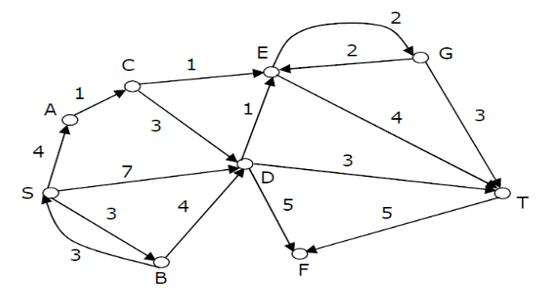](https://kmctce.etlab.in/outcomes/cobasedquestions/view/6635)](https://kmctce.etlab.in/outcomes/cobasedquestions/view/6635)

[22.Find an optimal solution to the knapsack instance n=7,m=15,(p1,p2,.....p7)=(10,5,15,7,6,18,3) and (w1,w2,.....w7)=(2,3,5,7,1,4,1).](https://kmctce.etlab.in/outcomes/cobasedquestions/view/6634)

[23.Is it possible to find all pairs of shortest paths using Dijkstra’s algorithm?  
Justify.](https://kmctce.etlab.in/outcomes/cobasedquestions/view/6633)

[24.Show Strassen’s matrix multiplication.](https://kmctce.etlab.in/outcomes/cobasedquestions/view/2991)

[25.Write an algorithm to merge two sorted arrays and analyse the complexity.](https://kmctce.etlab.in/outcomes/cobasedquestions/view/2989)

[26.Explain Divide and Conquer strategy with example.](https://kmctce.etlab.in/outcomes/cobasedquestions/view/2988)

[27.Write and explain merge sort algorithm using divide and conquer strategy using the data {30, 19, 35, 3, 9, 46, 10}. Also analyse the time complexity.](https://kmctce.etlab.in/outcomes/cobasedquestions/view/2368)

[28.Compare Divide and Conquer and Dynamic programming methodologies.](https://kmctce.etlab.in/outcomes/cobasedquestions/view/2986)

[29.Write an algorithm to merge 2 sorted arrays into a single sorted array](https://kmctce.etlab.in/outcomes/cobasedquestions/view/2987)

[30.Explain Divide and Conquer strategy with example.](https://kmctce.etlab.in/outcomes/cobasedquestions/view/2988)

[31.Write an algorithm based on divide-and-conquer strategy to search an element in a  
given list. Assume that the elements of list are in sorted order.](https://kmctce.etlab.in/outcomes/cobasedquestions/view/2365)

32.Develop the control abstraction for Divide and Conquer method

33. Formulate fractional Knapsack problem. Write greedy algorithm for fractional

Knapsack problem.Find optimal solution for the following Knapsack problem.

n=3, m=20, W={ 18,15,10 } , P={25,24, 20 }

34. Apply kruskals algorithms on the following graph. Let A be the source vertex.

Analyse complexity of each algorithm.

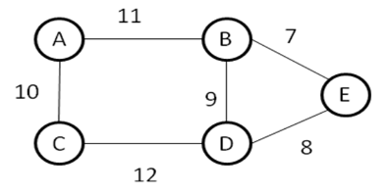

35. Formulate Fractional Knapsack Problem. Write Greedy Algorithm for fractional

Knapsack Problem.Find the optimal solution for the following fractional Knapsack problem. Given:number of items(n)=4, capacity of sack(m) = 60, W={40,10,20,24} and P={280,100,120,120}

**MODULE IV**

1.Find an optimal paranthesization of a matrix-chain product whose sequence of dimensions is 4x10,10x3,3x12,12x20,20x7.

2.Define Travelling Salesman Problem (TSP). Apply branch and bound technique to solve the following instance of TSP. Assume that the starting vertex as A. Draw the state space tree for each step.

3.Why Strassen’s matrix multiplication algorithm is better than traditional divide and conquer algorithm for multilpying two square matrices? What is the recurrence for the number of computational steps taken by Strassen’s algorithm and its time complexity?

4.[Discuss the control abstraction used in backtracking design technique. Draw the state space tree for 4-queens problem.](https://kmctce.etlab.in/outcomes/cobasedquestions/view/6591)

[5.Discuss Floyd-Warshall algorithm for all pair shortest path problem. Solve the following instance using the algorithm](https://kmctce.etlab.in/outcomes/cobasedquestions/view/6588)

[.[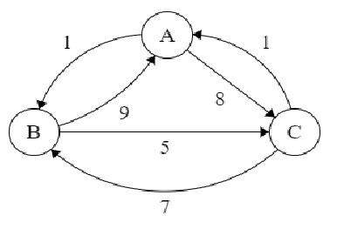](https://kmctce.etlab.in/outcomes/cobasedquestions/view/6588)](https://kmctce.etlab.in/outcomes/cobasedquestions/view/6588)

6.[Consider the following four matrices and perform chain matrix multiplication using the dynamic programming approach. Finally give the optimal cost of multiplication and optimal parenthesization.  
A       B       C       D  
4x5    5x3   3x2    2x7](https://kmctce.etlab.in/outcomes/cobasedquestions/view/6333)

7.[Define Travelling Salesman Problem. Solve the following instance of TSP using branch and bound technique. The cost matrix is given below:[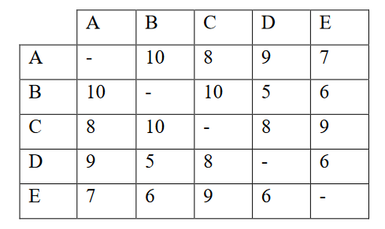](https://kmctce.etlab.in/outcomes/cobasedquestions/view/6332)](https://kmctce.etlab.in/outcomes/cobasedquestions/view/6332)

8.[Write Floyd Warshall algorithm for all pair shortest path problem and perform its complexity analysis.](https://kmctce.etlab.in/outcomes/cobasedquestions/view/6331)

9.[Explain about the structure of an optimal paranthesization of matrix-chain  
multiplication problem.](https://kmctce.etlab.in/outcomes/cobasedquestions/view/6313)

[10.Define Travelling Salesman Problem (TSP). Apply branch and bound algorithm to solve TSP for the following graph, assuming the start city as ‘a’. Draw the state space tree.](https://kmctce.etlab.in/outcomes/cobasedquestions/view/6312)

[[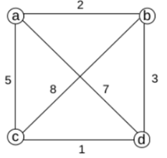](https://kmctce.etlab.in/outcomes/cobasedquestions/view/6312)](https://kmctce.etlab.in/outcomes/cobasedquestions/view/6312)

11.[What is Principle of Optimality?](https://kmctce.etlab.in/outcomes/cobasedquestions/view/6310)

12.[Find an optimal paranthesizationof a matrix-chain product whose sequence of dimensions is 4x10,10x3,3x12,12x20,20x7.](https://kmctce.etlab.in/outcomes/cobasedquestions/view/6632)

13.[Formulate fractional Knapsack problem. Write greedy algorithm for fractional  
Knapsack problem.](https://kmctce.etlab.in/outcomes/cobasedquestions/view/6631)

[14.Give the control abstraction of Greedy strategy.](https://kmctce.etlab.in/outcomes/cobasedquestions/view/5944)

15.[Consider the following instance of Fractional Knapsack problem with 3 objects.The capacity of the knapsack is 20 units. The weights and profits of the 3 items respectively are represented by the vectors (w1,w2,w3) =(18,15,10) and (p1,p2,p3)=(25,24,15). Using a greedy strategy compute the optimal solution to this instance.](https://kmctce.etlab.in/outcomes/cobasedquestions/view/4109)

16. Given a chain of 4 matrices <A1,A2,A3,A4> with dimensions <5X4>,<4X6>,<6X2>,<2X7> respectively. Using Dynamic programming find the minimum number of scalar multiplications needed and also write the optimal multiplication order.

**MODULE V**

1. Explain randomized quicksort and analyse the expected running time of randomized quicksort with the help of a suitable example?
2. Explain the need for randomized algorithms. Differentiate Las Vegas and Monte Carlo algorithms
3. State bin packing problem? Explain the first fit decreasing strategy
4. [Specify the relevance of approximation algorithms.](https://kmctce.etlab.in/outcomes/cobasedquestions/view/6647)
5. [Differentiate between P and NP problems.](https://kmctce.etlab.in/outcomes/cobasedquestions/view/6646)
6. [Write short notes on approximation algorithms](https://kmctce.etlab.in/outcomes/cobasedquestions/view/6645)
7. [Define Vertex Cover problem using an example. Suggest an algorithm for finding Vertex Cover of a graph.](https://kmctce.etlab.in/outcomes/cobasedquestions/view/6644)
8. [With the help of suitable code sequence convince Vertex Cover Problem is an example of NP-Complete Problem](https://kmctce.etlab.in/outcomes/cobasedquestions/view/6643)
9. [Define approximation algorithm. Give an approximation algorithm for bin packing using first fit heuristic and give its approximation ratio.](https://kmctce.etlab.in/outcomes/cobasedquestions/view/6642)
10. [Show that CLIQUE problem is NP Complete.](https://kmctce.etlab.in/outcomes/cobasedquestions/view/6641)
11. [Define bin packing problem. Discuss the first fit strategy for solving it. State the approximation ratio of the algorithm.](https://kmctce.etlab.in/outcomes/cobasedquestions/view/6640)
12. [Explain the benefits of randomized algorithm over deterministic algorithm.Discuss briefly the major categories of randomized algorithms. Give example for each category](https://kmctce.etlab.in/outcomes/cobasedquestions/view/6639)
13. [Prove that vertex cover problem is NP Complete.](https://kmctce.etlab.in/outcomes/cobasedquestions/view/6638)
14. [Identify the differences between Las Vegas and Monte Carlo algorithms.](https://kmctce.etlab.in/outcomes/cobasedquestions/view/6583)
15. [Identify P, NP and NP complete domains.](https://kmctce.etlab.in/outcomes/cobasedquestions/view/6582)
16. [Discuss briefly the elements of dynamic programming with a suitable example.](https://kmctce.etlab.in/outcomes/cobasedquestions/view/6341)

[17.Define graph colouring problem.](https://kmctce.etlab.in/outcomes/cobasedquestions/view/6316)

[18.Develop the need for approximation algorithm.](https://kmctce.etlab.in/outcomes/cobasedquestions/view/6315)

19.a) Define Travelling Salesman Problem (TSP).

b) Explain the basic steps that are to be followed to solve TSP using branch and

bound. Illustrate with an example.

20. Define NP-Hard and NP-complete problems.

21.What do you mean by intractable problems?

22.Write notes on polynomial time reducibility. Give examples.

23. What are approximation algorithms? Explain an approximation algorithm for

vertex cover problem.

24.Differentiate between deterministic and non–deterministic algorithms. Give non-

deterministic algorithm to perform sorting a set of integers in ascending order